TGA: A New Integrated Approach to Evolutionary Algorithms
Chuan-Kang Ting, Sheng-Tun Li and Chungnan Lee
IEEE Congress on Evolutionary Computation, pp. 917-924, 2001
Abstract
Genetic Algorithm (GA) is a well-known heuristic optimization algorithm. However, it suffers from the serious problem of premature convergence, which is caused mainly by the population diversity decreasing in evolution. In this paper, we propose a novel algorithm, called TGA, which integrates the memory structure and search strategy of Tabu Search (TS) with GA. As such, the selection efficiency is improved and the population diversity is maintained by incorporating the regeneration operator. The traveling salesman problem is used as a benchmark to evaluate TGA and compare it with GA and TS. Experimental results show that TGA gets the better performance than GA and TS in terms of both convergence speed and solution quality.
- GA
GA begins with an initial random population. Then genetic operators are applied iteratively to chromosomes in order to get better solutions (fitter chromosomes). The operators mimic the evolutionary mechanism in nature. First, the selection operator chooses a pair of chromosomes as parents. The probability of selection is in proportion to chromosome’s fitness value. The chromosomes with higher fitness have greater opportunities to be chosen, which fits the Darwin’s assumption: the fitter ones have more opportunities to generate more offspring. After parents are selected, one applies the crossover operator to exchange and recombine parts of the genes from parents to produce offspring. Finally, the mutation operator is applied to mutate some genes according to the mutation probability.
- Tabu Search
The basic components of Tabu Search are described as follows:
- Move: the process from one solution state to another
  - Neighborhood: the set of trial (candidate) solutions. The trial solution is defined as the solution that is related to current solution by a little permutation.
- Tabu List: it records the moves that are forbidden.
- Aspiration criteria: it makes the superior solutions have opportunity to overrides the tabu restriction.
- TGA
3.1 Representation

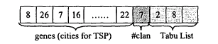
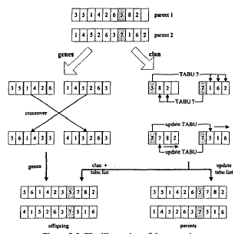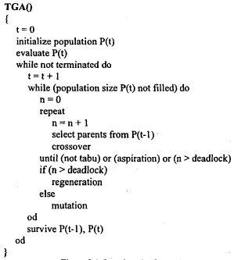

- Result

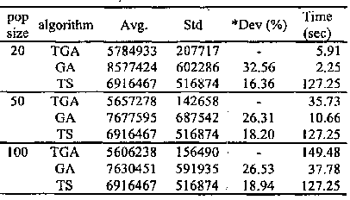
Created by : Chia-Chang Wang
Date : Jan. 7, 2005

